**CNM Grant Procurement Memo**

Applies to:

Funding source (choose one):

State Federal

* Federal purchases $10,000 and above or,
* State purchases $20,000 and above
* Purchases less than $60,000

**Grant/Project Title:** Dept of Education-Quantum Learning Lab

**Project Director/PI:** Brian Rashap

**Grant number within Workday:** GR300429

**Description of goods or services:** Short description of what is needed

Second Quantum Optics Education setup for the Quantum Learning Lab. Includes upgrades that allow student to explore more quantum phenomenon.

**Benefit to grant and CNM:** Describe how/why this purchase will meet objectives of project.

Increase the number of students able to be trained from 3 to 6, as well as add on capabilities around quantum phenomenon.

**Estimated dollar amount:** $48,247.76

**Rationale for method of procurement:** Describe how quotes were gathered

Direct Quotes from Vendors

**Contractor selection or rejection:**  Name each vendor and indicate whether selected or rejected. This will document and justify the decision for procurement.

* VENDOR #1: ThorLabs
  + ThorLabs: ACCEPTED
  + Amount of Quote: $48,247.76
  + Justification: Lowest Quote. Matches current setup and allows for expansion.
* VENDOR #2: QuTools
  + QuTools: REJECTED
  + Amount of Quote: $95,000 (or $65,000 without NV setup)
  + Justification: Move expensive and less compatible with learning objectives.
* VENDOR #3: Newport / MKS
  + Newport / MKS: REJECTED
  + Amount of Quote: $10,093.
  + Justification: Does not provide the capabilities needed for the Quantum Technician Bootcamp. Newport/MKS will not make it customized to meet our needs.

**VENDOR #1: ThorLabs**

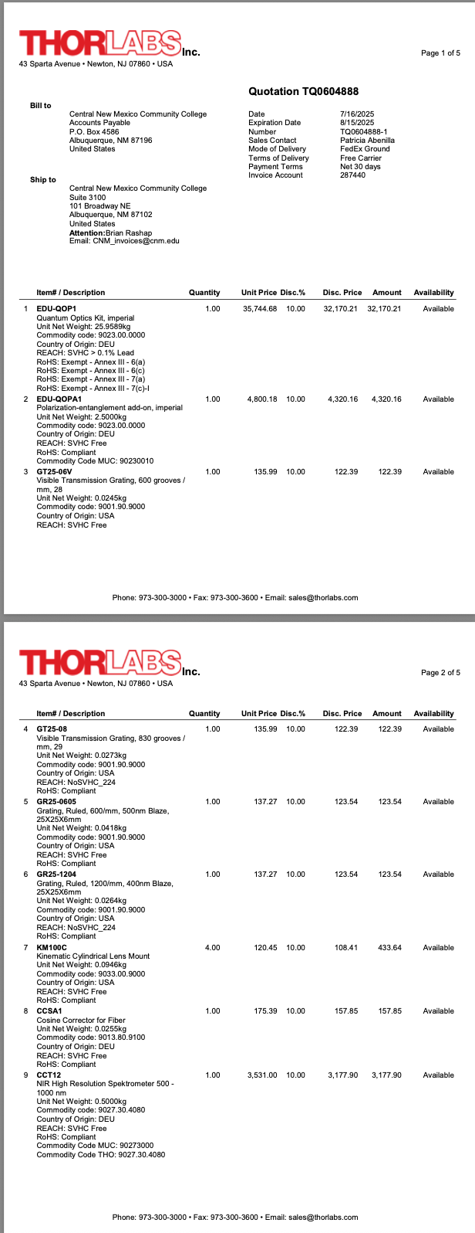

**VENDOR # 2**

**VENDOR #3: Newport / MKS**

Dear Brian,

We appreciate your interest in Newport, the Photonics Solutions Division of MKS Instruments, Inc. I am contacting you regarding your inquiry for the educational optics kit.

I understand you are interested in purchasing a kit that will allow for a wide range of different optical experiments.

Here we offer the OEK-STD Educational Kit: [https://www.newport.com/p/OEK-STD](https://urldefense.com/v3/__https:/www.newport.com/p/OEK-STD__;!!KGOTntw!ThCRNDR6QNFYhCDk-RO_NMDxdV474jt2X7D_Iiv3pu0N3R-numys82-yoicThreuAeDw6nLgN1Uoje_z-KemhWLqfh4$)

Unfortunately we do not offer any custom options for this kit but if you need help selecting additional optics or opto-mechanics we are happy to assist.

If you have any other questions or comments or interested in a quotation please let us know.

Your case number for future reference is 00822673.

Thank you,

**Steven Fontanini**

**Sr Inside Sales Engineer**

**Photonics Solutions Division**

**MKS Instruments, Inc.**

Phone : +1.720.459.9030

